|  |  |  |  |
| --- | --- | --- | --- |
| Module Code | DWD 506 | Module Title | DWD 506 Software Development |
| Student ID | 3201807 | Name | Jack Bradley-Coombes |

**DWD 506 – Software Development- Assessment 1**

In this assessment, you are to select and apply suitable design principles to design and plan a solution to the given scenario. Your designs must be structured and presented professionally which includes all the details required to meet the client’s requirements. With your Tutor’s approval, you will be only designing either the front-end or back-end solution for the client. The database requirements are compulsory in either case.

**Create a customised logo and colour scheme for the business. [4 marks]**

Colour Palette I’ve chosen uses a primary of red with supporting colours like black and white.



* **Design User-Interface, with mock-ups of all web pages for one screen size. Select one from desktop, tablet or mobile.**  **[10 marks]**

**Home Page:** Instead of including all available vehicles on the home page, I have chosen to just include things like the support car brands, and current sales, and have a separate dedicated page to list all vehicles. Links to other pages like the vehicle pages or logging in can be found on the nav bar.

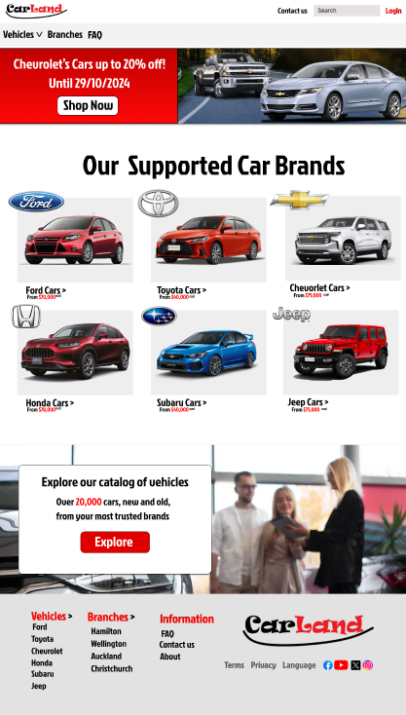

**Vehicles List:** This page is a list of all vehicles available on the database, with a filter option to find specific vehicles, and different pages to allow for large amounts of vehicles to be displayed.

**Account Register page:** This is the account creation page. There will be restrictions on the fields, like ensuring that the username and email address haven’t been registered already. A very similar page would be made for a login page as well. An option to add to wish list or learn more about the vehicle is available for each display.

**Car Details:** This page is an example of what you would see when you click on a specific car your interested. This page will include the price, and other specifications about the specific vehicle, as well as availability in different Carland branches.

**Wishlist page:** This page will only be accessible to a logged in user. Once a user adds a product to the wish list it will show up here, where they can see all wish listed products, allowing quick access to them, or an option to remove them from the wish list.

**Admin Panel:** The admin panel will only be available to users marked as admin, which can be given to accounts inside the admin panel, or in the database.

**Users page:** this page shows all registered users, as well as their information like name, wish listed items, and if there an admin or not. Options to access other admin panel options are available on the side bar.

**Vehicles List:** The admin panel list of vehicles allows for viewing off all vehicles in the database, as well as the option to edit the listings through the pen button. Under the edit button it will allow options like changing the listing name, editing the price, or deleting the listing. The option for adding new listings is also available on this page.

**Plan a suitable relational database schema and present it using an Excel sheet. This means no repeated information wherever possible, and data divided into appropriate tables. Be sure to specify the correct data types, keys and indexes**

**such as auto increment in your plan. [10marks]**

I created three database examples for the mock-up, Vehicle database, user database, and wish list database. In the column titles I have included if they are primary key, foreign key, or unique. Primary keys will be auto incrimented and do not allow for dulpicates. Neccesary information is marked to not allow null information. Each table has a primary key, and the wishlist table uses two foreign keys. The email address section in the user data base is marked as unique as it doesn’t allow duplicate entries, as an email can only be linked to one account.

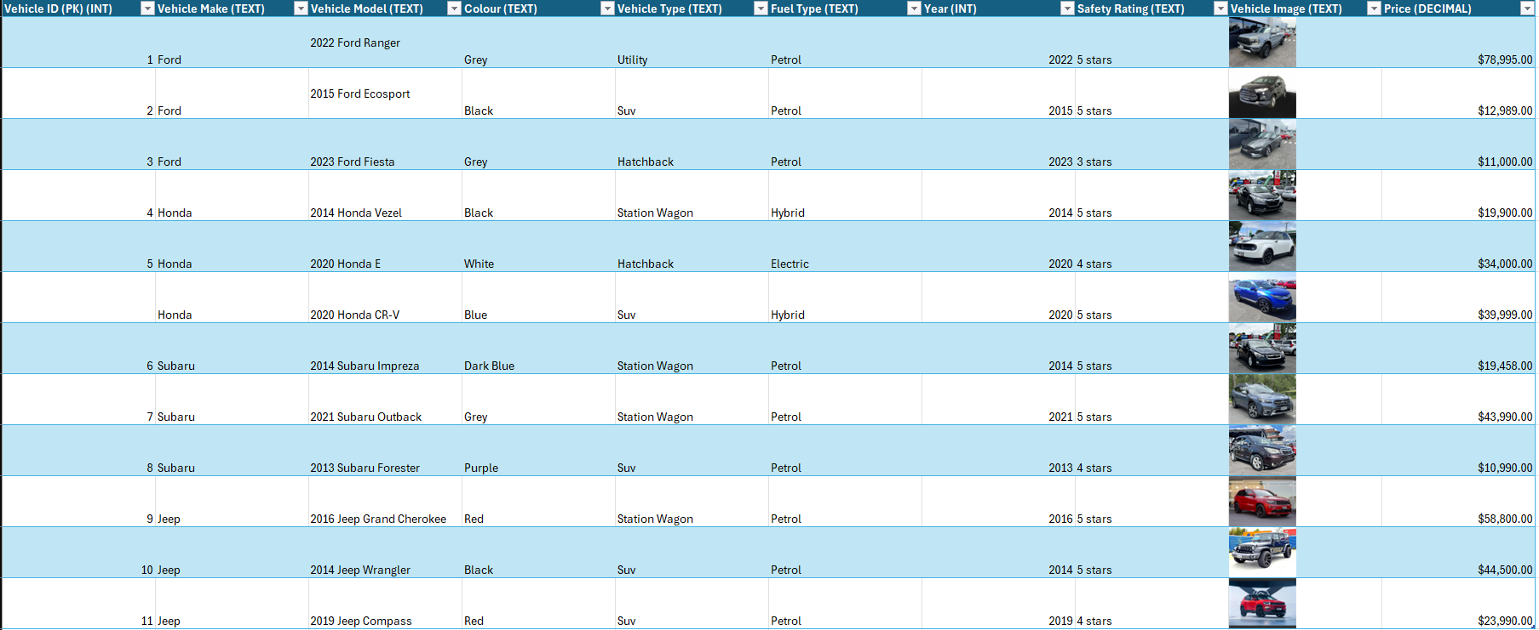

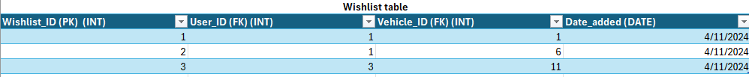



**Outline the three visual design principles you considered and how you applied them.** **[6 marks]**

I considered **contrast** first when choosing the colour scheme for the website. I decided on red, white and black. White and black can be used for the bulk of the website, then red is used to draw the users’ eyes towards important areas, like advertisements, or sales.

The next design principle I considered was **whitespace.** I added white space between each section, giving the website more readability.

Lastly, I implemented balance, placing each section deliberately to allowing the page an even distribution of different sections, making the design more pleasant to look at.

Client Requirements –

**Front end**

* **Home page showing all vehicles from Database**

*Vehicles from the database are listed on the “vehicles” page instead of home page.*

* **Browse** **single-vehicle details**

*Each vehicle on the database has its own webpage with all the vehicles details the customer would require.*

* **User should be able to sign up and log in to gain Wishlist functionality**

*The top right of the navbar features a login button, which allows users to, either register an account, or login to their previously made account*.

* **Ability to add vehicles to the Wishlist (only for registered users)**

*Both the vehicle list page and the individual vehicle pages both have a little flag button which adds the product to Wishlist. However, any user that isn’t logged in will instead be redirected to a login page.*

* **Ability to delete vehicles from the Wishlist (only for registered users**)

*Once a vehicle is in the user’s wish list, the previous icon will gain a cross through it, upon clicking this new icon, it will remove the product from the wish list. Items can be removed from wish list on the vehicle list page, individual vehicle page, wish list page, or through the admin panel (requires admin permissions)*

**Database**:

Create a database to hold vehicles and other necessary information such as user, Wishlist, staff etc.

Vehicle Details minimum requirements include:

* Vehicle make (e.g. Honda, Subaru, Jeep) o Vehicle model
* Colour
* Type (e.g. saloon, hatch, SUV, truck)
* Fuel type (e.g. petrol, diesel, electric, hybrid, bio …)
* Year (e.g. 1989, 1956) o Safety Rating (e.g. Honda Civic has a safety rating of 4/5, Subaru Legacy a rating of 3/5 and so on)
* Vehicle image
* 4 makes and 3 models of each make.

**Back End:**

Secured administrator pages that allow the following functionality:

* Login page for Admin
* Home page showing all vehicles from the database
* Add new vehicle data
* Edit vehicle details
* Delete vehicle data